

SMART STAR EXAMINATIONS BOARD

**BEGINNING OF TERM I EXAMINATION – 2024**

P.3 MATHEMATICS

***Time allowed: 2 hours 30minutes***

NAME_____________________________________STREAM_______

SCHOOL________________________________________________

**SECTION A (*2 marks each*)**

1. Add:7 + 2 =___________________

2. Write 35 in words.

3. Write the next number.

15, 25, _____, 45, 55.

4. **Shade:** set BA

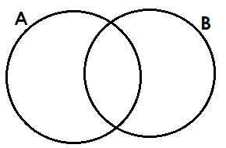

5. **Fill in the missing number**

-2 = 6

6. **Study the table below**

|  |  |  |  |
| --- | --- | --- | --- |
| Name | zoe | loy | Tim |
| Mark | 46 | 80 | 65 |

What was the highest mark?

________________________________________________________

7. **Name the unshaded fraction**

8. **How many squares are in the figure below?**

9. **Subtract:** Sh. 600

-Sh. 400

10. **Draw a kite in the space below.**

11. **Arrange in descending order.**

1, 4, 5, 0, 6

……………………………………………………………………….

12. **Multiply:** 5 3

X 2

13. **Name the shape of a chapatti.**

………………………………………………………………………..

14. **Show the time.**

It is 7 o’clock

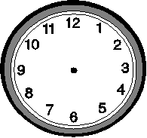

15. **Name any one feature found on a two hundred shilling coin.…………………………………………………………**

16. **Find the missing number**

6 - = 2

17. **Write next number.**

20, 40, 60, _____, 100

18. **How many weeks are in 14 days?**

**_______________________________________________________**

19. **Draw the set symbol for union set**

20. **Name the shape below;**

**___________________________________**

**SECTION B (60 Marks)**

21. **Work out:(2mark each)**

a) = ____ c) = ______

b) +

22. **a)** Fill in tens and ones.(**2marks)**

= ____ tens ____ ones

b) ____hundreds _____tens and ____ones = 645 **(2marks)**

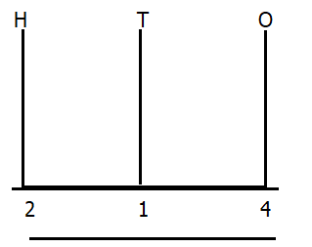 c) Complete correctly  **(1mark)**

23.Annet had 163 sweets, Joel had 184 sweets and Sarah had 24 sweets. Complete the table correctly. **(3marks)**

|  |  |  |  |
| --- | --- | --- | --- |
| Name | Joel | Sarah | Annet |
| Sweets | _________ | __________ | ___________ |

b) How many sweets does Annet and joel have altogether?**(2marks)**

24. **Harriet went to the market and bought the following items.**

**E**

**F**

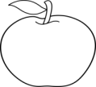





a)Set E has ___________________________ members.(**1mark)**

b)Set F has _______________ members than E. (**1mark)**

c) How many members are in both set E and set F altogether?(**2marks)**

_______________________________________________________

25. **Study Annet’s shopping list and answer the questions that**

**`follow**

|  |  |
| --- | --- |
| **Item** | **Cost** |
| Sugar | Sh. 1000 |
| Rice | Sh. 500 |
| Salt | Sh. 300 |
| Bread | Sh. 600 |

a) Whose shopping list is shown above? **(1mark)**

_________________________________________________________

b) How much was the most expensive item?(**2marks)**

__________________________________________________________

c) How much did Annet spend on Rice and salt?**(2marks)**

_______________________________________________________

26.a) **Expand these numbers. (2marks each)**

383=…………………………………………..

42 = …………………………………………

b) **Write in words.(2mar**ks)

724 = ………………………………………………….

27. **The bar graph below shows the number of pupils who**

**collected different number of books.**

70

**Number of books**

60

50

40

30

20

10

**Aisha**

**Agnes**

**Amina**

**Alex**

**Annet**

0

**Names of pupils**

a) Who got the lowest number of books? **(1mark)**

_______________________________________________________________________________________________

b) _____________ and __________ got the same number of

books.  **(1mark)**

c) How many more books did Amina get than Aisha? **(2marks)**

__________________________________________________________________

d) Who got 20 books?_____________________________________**(1mark)**

28.Annet had 20 pencils, she gave Joseph 10 pencils. How many

pencils did she remain with? **(2marks)**

b)A farmer had 40 cows. He bought 15more cows. How many cowsdoes he have altogether? **(2marks)**

c) **Work out:**

24 x 3 = **(1mark)**

29. Use the shape below to answer the questions

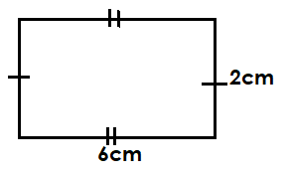

a) Name the shape **(1mark)**

____________________________________________

b) How many sides does the shape above have? **(1mark)**

______________________________________________

c) What is the length of the shape? **(1mark)**

_______________________________________________

d) Find the area of the figure above.**(2marks)**

30. **Match correctly.**  **(1mark each*)***

$\frac{1}{2}$ twelfth

$\frac{1}{4}$ a whole

$\frac{1}{3}$ half

1. a quarter

$\frac{1}{12}$ a third

31. **Fill in correctly (1mark each)**

**_______**

_________

4

_____

**2**

**3**

**12÷**

1

**_________________________**

32. **Below are two cups which have different capacities**

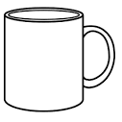

**D**

**C**

**5Litres**

**10Litres**

a) Which cup holds more water?**(1mark)**

____________________________________________________

b) How much water was collected in cup **C** and cup **D**

altogether?**(2marks)**

­­­­­­­­­­­­­­­__________________________________________________

c)How much more water is in cup C than cup D?**(2marks**)

_____________________________________________________

**END**